Issues with reserved space option.

Using Build 1355
Device attached through the d_USBMass1.dll (Device is a mapped SMB share)
AutoSync set to not delete contents before sync
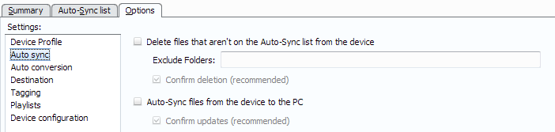

- If you clear the value (in entry box not check box) it throws an error.
- If you enter any non-numeric character (not 0-9) it throws an error.
- Any number > the actual free space when the drive was scanned gets treated as the actual free space. (Sample below had 1000mg free)
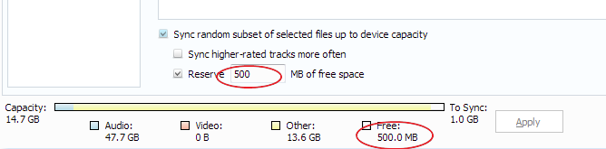
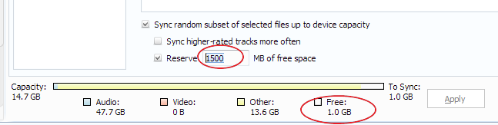
- When you change the values the “Apply” button does not activate (you have to uncheck/recheck one of the options to get it to activate. If you leave the screen without hitting “Apply” the value is not saved.
- If the number is greater than the current available space on the device the entire device is filled.
  - Device was synced to reserve 950mb
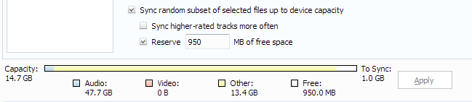
  - Worked correctly.
  - Changed to not keep 960mb available (note unchecked/checked to allow “Apply”.
  - Even though the drive has less than the amount reserved available it creates a list and starts to fill the drive. See below that 771 files are queued to be sent. The same thing happens if a file was created by the device after the initial scan (fills the whole drive)
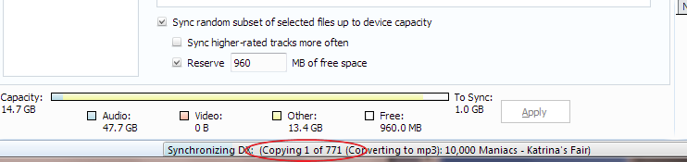
- The capacity gauge seems to not reflect the settings/values correctly.
  - If the Capacity is 14.7GB how is 47.7GB shown as a small portion of the drive.
  - In the case above the 13.4GB listed as other are actually the Audio files that MM synced to the drive.
  - The reserved space seems to be listed as the “Free” space. If you change the reserved the “Free” changes in the gauge.
- I didn’t find any way to force a rescan.

Note that after closing/re-opening MM the Gauge is showing different values and when I did a sync it started to “delete old content” even though I have it set to not do this. I double checked the settings (turning them on then off again) and tried another sync and it started to delete content. At this point I gave up on the syncing until these issues are resolved. I’ll manually select the files I want on the device.

